Learning Journal Unit 6

Godfrey Ouma
University of the People
MATH 1201: College Algebra
Yousef Ajeeb
October 19, 2023

Learning Journal Unit 6
- Reflect on the concepts of linear and non-linear systems. What concepts (only the names) did you need to accommodate the concept of linear and non-linear systems in your mind?
To better understand linear systems, they have a degree of one and their graph forms a straight line. A linear system takes the form $ax+by+cz=d$, where a, b, c, and d are constants while x, y, and z are the variables. On the other hand, I understand a non-linear system by looking at if the degree is 2 and their graph can form either a parabola or circle. A non-linear system can take the form $ax^{2}+by+cz=d$ for a parabola and ${ax}^{2}+{by}^{2}=d$ for a circle, where a, b, and d are constants while x and y are the variables.
- What are the simplest linear system and non-linear system you can imagine?
The simplest linear system can be $x+y+z=8$ and the simplest non-linear system can be $x^{2}+y+z=10$ or $x^{2}+y^{2}=25$. See the graph of these system of equations below. Using the colour codes, the red graph represents the linear system while the blue graph represents the non-linear system.
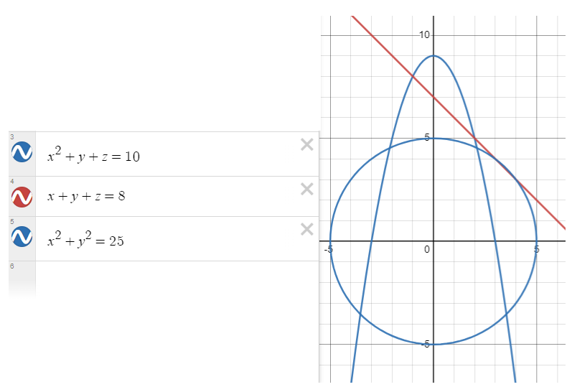
- In your day to day, is there any occurring fact that can be interpreted as linear systems and non-linear systems?
In educational context, predicting future school enrollment based on current trends can be modeled as a linear system. The increase or decrease in the number of students over time can be estimated linearly. To represent the number of students (enrollment) as a function of time (years)., the linear equation might look like this: $E(t)=mt+b$ Where:
- E(t) is the predicted enrollment at time t in days.
- m is the slope of the line, representing the rate of enrollment.
- b is the y-intercept, representing the initial enrollment at a specific time.
For instance, if the new school starts with a population of $b=10$ on day one and expected rate of enrollment $m=2$ (representing 2 students per day new enrollment), the linear system representing this situation can be modelled as follows: $E(t)=2t+10$
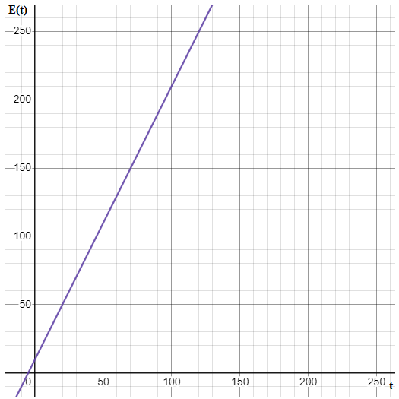
From the graph above, it will take 120 days for the school to reach population of 250 students if the rate of enrollment remains constant. Therefore, modelling a linear system in this case would guide the school administration on how to plan with their budget such as feeding program and resource allocation as time progresses.
On the other hand, determining the optimal class size for effective teaching and learning may require non-linear modeling. Parabolic equations can help schools identify the class size at which student outcomes (e.g., test scores, engagement) are maximized before diminishing returns set in. Considering the relationship between class size and student outcomes, a non-linear equation might look like this: $O(c)={ac}^{2}+bc+d$, where:
- O(c) represents the student outcomes, which could include factors like test scores, engagement, or overall performance.
- c is the class size, which is the variable we want to optimize.
- a, b, and d are coefficients that determine the shape of the parabola.
Assuming the non-linear system for determining the maximum size of the class is:
$O(c)={-c}^{2}+2c+24$, and the graph shown below.
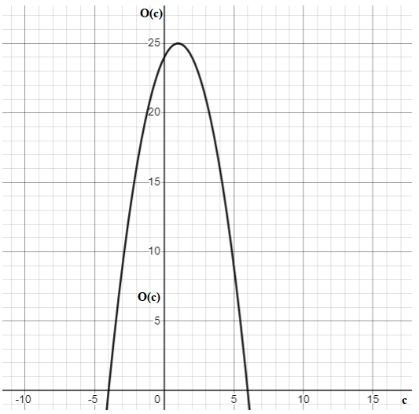

Based on the non-linear system represented in the graph above, the maximum class size is set to be 25 student beyond which the quality of teaching will be compromised. By applying this non-linear system, schools can find the class size that balances the benefits of smaller class sizes (more individual attention) and larger class sizes (resource efficiency). This can help educational institutions make data-driven decisions to improve teaching and learning outcomes.
- What strategy are you using to get the graph of linear systems and non-linear systems?
Drawing a table for the points to plot on the graph then join the plotted point to obtain the linear and non-linear graph. See the table below.
$$x$$ | 1 | 2 | 3 | 4 | 5
$$f(x)$$

